Board of Directors Meeting
Wednesday, February 3, 2021
11:00am – 1:00pm
Zoom Conference Call
https://zoom.us/j/95315967992 (PC: CPRSZoom)

- Welcome & Call to Order
- Review & Approve
  - Meeting Minutes – Review & Approve January
  - Financial Reports – Review & Approve January
- Old Business
  - CPRS Membership Scholarship (CARE Scholarship)
- New Business
  - Resource Manual Updates – Review & Approve
- Committee Reports
  - 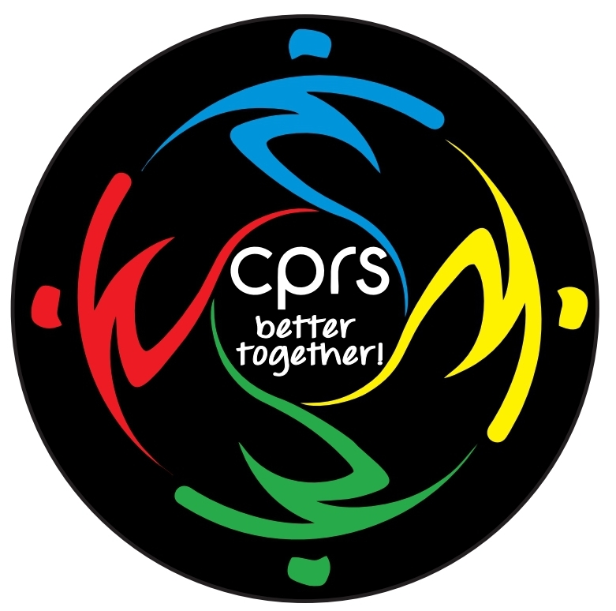Elections (Danny)
  - Lunch ‘n Learns (Kaisa)
  - Awards Program (Mark) – Deadline: February 4
  - Professional Grants & Student Scholarships (Mark)
    - Jane Adams Round #2 – Deadline: February 26
  - General Membership Meeting (J) – January 28
  - Awards & Installation Banquet (J) – Video Update
- Section & Additional Group Reports
- State Board Update – Tara Gee
- Region 1 Update
  - CPRS Region 1 Rep Update – Adam Chow
- Aquatics Section (Kate)
  - NCAMA – (Colin)
- Recreation Section (Eric B.)
  - YTRS (Pres. Eric B.)
- Administrators Section (Traci)
- Aging Services & Activities Section (Ian)
- Development & Operations Section (Patrick)
- Educators Section (Erik)
- Students Section (Elle)
- Recreation Therapy Section (Alivia)
- Advocacy Update (Phillip)
- Partnership for Quality Living (Danny)
  - PQL updated on Awards & Installation Banquet Video Plans
- “Open Space”
- Adjournment

